IKEA Seat for Ten

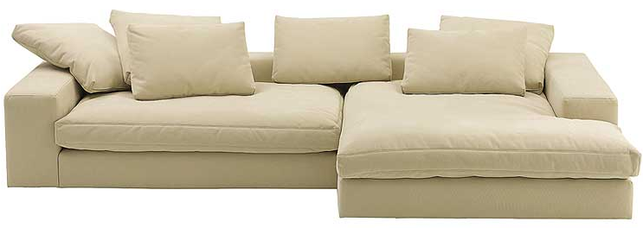

|  |
| --- |
| **DESCRIPTION** |
| Large pressed Sofa designed by IKEA, presents a sleek, low profile design that is both Supporting and very comfortable. The extra soft cushion relaxes the body and adjusts the weight of the body. No legs on bottom provide 100 percent stability for the sofa. With its natural design and mediocre performance provides the soft with good durability which maintains the position of this growing object. |

|  |  |  |
| --- | --- | --- |
| **Price** | **3600$** | |
| **Dimensions** | **H** x **W** x **L** | **15in x 30in/32in x 85in total** |
| **Features** | **It can support the weight of more than 10 people sitting together the extra wide space acts as a bed to which a person can relax.** | |
| **Finished** | **Leather Touch** | |
| **Available in** | **Off-white and Light Brown** | |